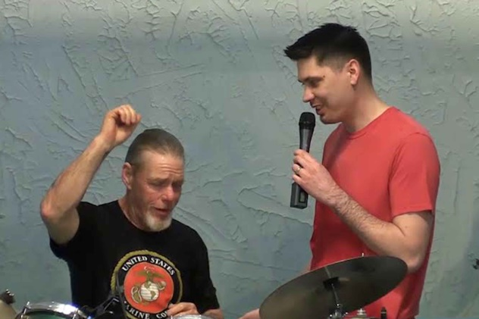
Foundations of Baptisms
Why Does God Want
You to Get Baptized?
Pastor Mark Schwarzbauer PhD
Family Worship Center 5/8/16

Text: Hebrews 6:1-3

Part One: The Foundation of Baptisms
- Hebrews 6.
- Foundation of Repentance.
- The Verb (action word) Metanoeo means to change one’s mind and purpose, as the result of acquired knowledge. Used with the cognate noun Metanoia to indicate true repentance. You change your lifestyle to reflect that you have changed your mind to thinking God’s way.
- From dead works of thinking you can save yourself to faith - relying on the completed work of Christ on the cross.
- The doctrine of baptisms is PLURAL.
A. The first is baptism in water.
B. The second is the baptism in the Holy Spirit.
- After you repent and accept Christ and are saved you then should be baptized in water.
A. Jesus in Mark 16:15-16.
B. Acts 2:38 38.
C. Repentance and believing come first.

Part Two: The Purpose of Water Baptism
- The purpose of water baptism is to symbolize the transformation you have experienced in Christ and to publicly proclaim your personal faith.
- The symbolization of baptism.
- Romans 6:1-4.
- The symbolism of Baptism.
- Baptized into Jesus’ death – symbolized in being immersed into the water - declaring that what Jesus did on the cross was for you.
- Therefore… we are buried with Him - symbolized in being under the water – declaring your old life is over.
- Raised with Jesus – symbolized in coming up from under the water ~ declaring you are a new person in Christ.
- Walking in a new life – symbolized in stepping out from the water – you have a new lifestyle of truly following God.
- I Peter 3:21. External representation of internal experience,
- The public proclamation of your personal faith.
- What about baptism as a baby?
A. It is wonderful when parents acknowledge the importance of spiritual life for their children. Really, this is dedicating the child to God and scripturally, babies should be dedicated to God.
B. There is not one scripture calling babies to be baptized. Baptism is for those who have made a personal choice to follow Jesus and are able to make a public declaration of personal faith.

Part Three: Why Does God Want YOU to Get Baptized?
- In obedience to God’s command and in following Christ’s example.
- Obedience always brings blessings.
- Baptism builds confidence as it reinforces and strengthens your faith and testimony.
- Baptism gives you a wonderful outreach opportunity as you share your testimony.
- Baptism releases spiritual power just as it did when Jesus was baptized.
1. Matthew 3:13-17.
2. Jesus didn’t need to be baptized as He never sinned.
3. Jesus set the example for you.
4. The power of heaven was opened for Him.
5. The same power awaits you as you follow Jesus.

Closing…

Discussion Items and Questions for Home and Small Group
1. Discuss why baptism as a believer is important.
2. Why do you think Jesus wanted to be baptized when He was the only one who didn’t need it?
3. If you haven’t done so already, please fill out the worksheet.
4. If you haven’t been baptized yet as a believer please turn in your request form.

Why Does God Want You to Get Baptized?
Worksheet ~ Family Worship Center

This worksheet is designed to accompany the outline and message video “Why Does God Want You to Get Baptized?”.

Hebrews 6:1-3 starts with “repentance” before baptism. In your own words, what does it mean to “repent”?

Mark 16:15-16 says that “He who ________________ and is _________________ will be saved.

Acts 2:38 tells us “Repent and _______ _________ one of you be ______________...”

Repentance and believing _________ ________.

Who should be baptized according to Acts 2:38? ___________ _______.

The purpose of water baptism is to _________________ the _____________________ you

have experienced in Christ and to _____________ ______________ your personal faith.

The symbolization of baptism according to Romans 6:1-4 includes

1. To be immersed into the water symbolizes being “baptized” or immersed into Jesus death

declaring that what Jesus did on the cross __________ _______ _______.

2. Being under the water symbolizes we are _________ with ______.

3. Coming out from under the water symbolizes being _______ with _______.

4. Stepping out of the water symbolizes _____________ in a ________ __________.

To be “baptized” as an infant shows your parents recognized the importance of spiritual influence in your life. Dedicating children to God is biblical. However, there is not one scripture calling for babies to be baptized.
Baptism is for those who have made a _____________ __________ to follow Jesus and are able

to make a ___________ ______________ of _______________ ___________.
Why Does God Want ME to Get Baptized?

In obedience to God’s ______________ and in following ____________ ______________.

Obedience always brings ______________.

Baptism builds confidence as it reinforces and strengthens your __________ and_____________.

Baptism gives you a wonderful ____________ ________________ as you share your testimony.

Baptism releases ________________ ___________ just as it did when Jesus was baptized.

Baptism Request Form – Family Worship Center
Full name for Baptismal Certificate:

_____________________________________________________________________________

Date of birth__________ When did you accept Christ as your personal savior?______________

Briefly share your personal testimony of how you came to faith in Christ___________________

Share your personal reasons for being baptized_______________________________________

How has being at Family Worship Center helped you in your life?_________________________

Date you would like to request to be baptized_____________________________
If you wish to be baptized please give this sheet to Pastor Mark or Pastor Phil

