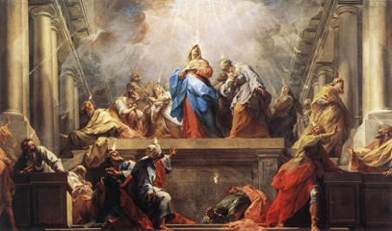
The Sweet Sound
of Surrender
Pastor Mark Schwarzbauer PhD
Family Worship Center 6-11-17
Jean II Restout - Pentecost

Acts 2:1-4 When the Day of Pentecost had fully come, they were all with one accord in one place. 2 And suddenly there came a sound from heaven, as of a rushing mighty wind, and it filled the whole house where they were sitting. 3 Then there appeared to them divided tongues, as of fire, and one sat upon each of them. 4 And they were all filled with the Holy Spirit and began to speak with other tongues, as the Spirit gave them utterance.

Part One: The Baptist IN/WITH the Holy Spirit
- I encourage anyone with questions to view Pentecost 101 and 102 as well as other messages online
at http://i-fwc.com/Media/archive.html or http://www.drmark920.com/Theo110.html
- This experience of Pentecost and Baptism in the Holy Spirit is in all 4 Gospels and Acts.
A. Matthew 3:11 “I indeed baptize you with water unto repentance, but He who is coming after me is mightier than I, whose sandals I am not worthy to carry. He will baptize you with the Holy Spirit.”
B. Mark 1:8 “I indeed baptized you with water, but He will baptize you with the Holy Spirit.”
C. Mark 16:17 Jesus was the first to promise speaking in tongues for believers saying “they will speak with new tongues;”
D. Luke 3:16 “John answered, saying to all, “I indeed baptize you with water; but One mightier than I is coming, whose sandal strap I am not worthy to loose. He will baptize you with the Holy Spirit and fire.” (Note: Acts 2- the “Tongues” came as “fire”).
E. John 1:32-33 And John bore witness, saying, “I saw the Spirit descending from heaven like a dove, and He remained upon Him. 33 I did not know Him, but He who sent me to baptize with water said to me, ‘Upon whom you see the Spirit descending, and remaining on Him, this is He who baptizes with the Holy Spirit.’
F. Acts 1:5 Jesus said “for John truly baptized with water, but you shall be baptized with the Holy Spirit not many days from now.”
G. For the many fulfillments of the Baptism in the Holy Spirit with the Initial Physical Evidence of Speaking with other Tongues see Acts 2, 8, 9,10,11,19
- The Initial Physical Evidence of the Baptism with the Holy Spirit is always speaking in other tongues. please see Pentecost 101 and 102. We don’t measure God’s Word by our experience. We measure our experience by God’s Word.
- The Release of the Holy Spirit already inside of you.
- You receive the Holy Spirit inside of you the moment you are born-again (John 20:22). The experience of the Baptism in the Holy Spirit is a separate, subsequent experience available for all believers (Acts 2:39).
- Almost one Billion (1 in every 7 people) is a Pentecostal or Charismatic Christian who believes in and speaks in a prayer language they have never learned.
- Fr. Dennis Bennett in his book “How to Pray for the Release of the Holy Spirit” explains how the Baptism in the Holy Spirit is a release of the Holy Spirit who already lives inside of you as a believer.
- The time of receiving.
- Some receive it shortly after being born again (The disciples about 47 days later).
- Some experience it years later.
- Jesus encouraged the disciples to wait in Jerusalem for this promise from the Father.
- Why the difference?

Part Two: Why it is Difficult for Some People to Release
- People sometimes have difficulty releasing to the Holy Spirit for various reasons.
- I prayed many months for it.
- Jack Hayford wrestled with it for 3 years.
- Sometimes it is fear that causes us to hold back.
- Sometimes it is concern over losing control.
- Sometimes it is a misunderstanding of how the release comes.
- Let’s help overcome these barriers.
- Special testimony from Stacy.
- How long had you sought the Baptism in the Holy Spirit?
- What do you think hindered your release?
- What brought about your surrender and release?
- How did it happen for you?
- What difference has it make in your life?
- What would say to encourage others to continue seeking?
To be continued next week
Closing ~ If you have already received the Baptism in the Holy Spirit with the initial physical evidence of speaking in tongues then exercise your gift. If you have not received continue seeking God and surrender.
Discussion Items and Questions for Home and Small Group
1. Was there something that made you, or still makes your hold back when it comes to prayer for the Baptism in the Holy Spirit?
2. Explain some of the common misunderstandings.
3. In your own words, explain why someone doesn’t need to fear losing control.
4. If you are Baptized in the Holy Spirit take time to exercise your prayer and worship language. If you are not yet Baptized in the Holy Spirit, please pray for the release and yield yourself to Him.

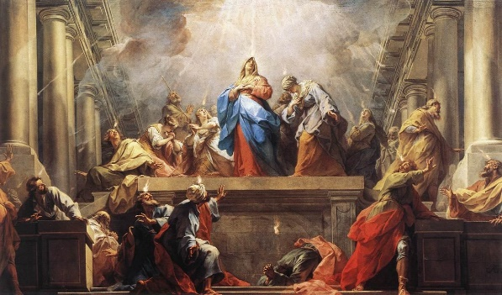
The Sweet Sound of Surrender
Pastor Mark Schwarzbauer PhD
Family Worship Center 6-11-17
Jean II Restout - Pentecost
Acts 2:1-4
Part One: The Baptist IN/WITH the Holy Spirit
- I encourage anyone with questions to view Pentecost 101 and 102 as well as other messages online at http://i-fwc.com/Media/archive.html or http://www.drmark920.com/Theo110.html
- This experience of Pentecost and Baptism in the Holy Spirit is in all 4 Gospels and Acts.
A. Matthew 3:11, B. Mark 1:8
C. Mark 16:17 Jesus was the first to promise speaking in tongues for believers
D. Luke 3:16 (Note: Acts 2- the “Tongues” came as “fire”).
E. John 1:32-33, F. Acts 1:5
G. For the many fulfillments of this in Acts 2, 8, 9,10,11,19
- The Initial Physical Evidence of the Baptism with the Holy Spirit is always speaking in other tongues. please see Pentecost 101 and 102. We don’t measure God’s Word by our experience. We measure our experience by God’s Word.
- The Release of the Holy Spirit already inside of you.
- You receive the Holy Spirit inside of you the moment you are born-again (John 20:22). The experience of the Baptism in the Holy Spirit is a separate, subsequent experience available for all believers (Acts 2:39).
- Almost one Billion (1 in every 7 people) is a Pentecostal or Charismatic Christian who believes in and speaks in a prayer language they have never learned.
- Fr. Dennis Bennett in his book “How to Pray for the Release of the Holy Spirit” explains how the Baptism in the Holy Spirit is a release of the Holy Spirit who already lives inside of you as a believer.
- The time of receiving.
- Some receive it shortly after being born again (The disciples about 47 days later).
- Some experience it years later.
- Jesus encouraged the disciples to wait in Jerusalem for this promise from the Father.
- Why the difference?
Part Two: Why it is Difficult for Some People to Release
- People sometimes have difficulty releasing to the Holy Spirit for various reasons.
- I prayed many months for it.
- Jack Hayford shared he wrestled with it for 3 years.
- Sometimes it is fear that causes us to hold back.
- Sometimes it is concern over losing control.
- Sometimes it is a misunderstanding of how the release comes.
- Let’s help overcome these barriers.
- Special testimony from Stacy.

Closing: If you have already received the Baptism in the Holy Spirit with the initial physical evidence of speaking in tongues then exercise your gift. If you have not received continue seeking God and surrender.

Discussion Items and Questions for Home and Small Group
- Was there something that made you, or still makes your hold back when it comes to prayer for the Baptism in the Holy Spirit?

- Explain some of the common misunderstandings.

- In your own words, explain why someone doesn’t need to fear losing control.

- How did Stacy’s testimony encourage you?

- If you are Baptized in the Holy Spirit, please take time to exercise your prayer and worship language. If you are not yet Baptized in the Holy Spirit, please pray for the release and yield yourself to Him.

