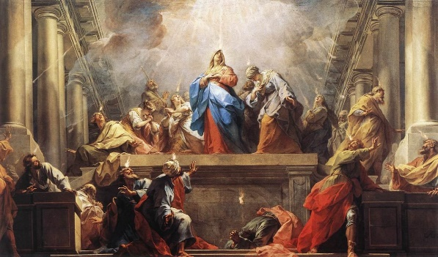
The Sweet Sound of Surrender
Pastor Mark Schwarzbauer PhD
Family Worship Center 6-8-17
Jean II Restout - Pentecost

Acts 2:1-4

Part One: The Baptist IN/WITH the Holy Spirit
- I encourage anyone with questions to view Pentecost 101 and 102 as well as other messages online at http://i-fwc.com/Media/archive.html or http://www.drmark920.com/Theo110.html
- This experience of Pentecost and Baptism in the Holy Spirit is in all 4 Gospels and Acts.
A. Matthew 3:11, B. Mark 1:8
C. Mark 16:17 Jesus was the first to promise speaking in tongues for believers
D. Luke 3:16 (Note: Acts 2- the “Tongues” came as “fire”).
E. John 1:32-33, F. Acts 1:5
G. For the many fulfillments of this in Acts 2, 8, 9,10,11,19
- The Initial Physical Evidence of the Baptism with the Holy Spirit is always speaking in other tongues. please see Pentecost 101 and 102. We don’t measure God’s Word by our experience. We measure our experience by God’s Word.
- The Release of the Holy Spirit already inside of you.
- You receive the Holy Spirit inside of you the moment you are born-again (John 20:22). The experience of the Baptism in the Holy Spirit is a separate, subsequent experience available for all believers (Acts 2:39).
- Almost one Billion (1 in every 7 people) is a Pentecostal or Charismatic Christian who believes in and speaks in a prayer language they have never learned.
- Fr. Dennis Bennett in his book “How to Pray for the Release of the Holy Spirit” explains how the Baptism in the Holy Spirit is a release of the Holy Spirit who already lives inside of you as a believer.
- The time of receiving.
- Some receive it shortly after being born again (The disciples about 47 days later).
- Some experience it years later.
- Jesus encouraged the disciples to wait in Jerusalem for this promise from the Father.
- Why the difference?
Part Two: Why it is Difficult for Some People to Release
- People sometimes have difficulty releasing to the Holy Spirit for various reasons.
- I prayed many months for it.
- Jack Hayford shared he wrestled with it for 3 years.
- Sometimes it is fear that causes us to hold back.
- Sometimes it is concern over losing control.
- Sometimes it is a misunderstanding of how the release comes.
- Let’s help overcome these barriers.
- Special testimony from Stacy.

Closing: If you have already received the Baptism in the Holy Spirit with the initial physical evidence of speaking in tongues then exercise your gift. If you have not received continue seeking God and surrender.

Discussion Items and Questions for Home and Small Group
- Was there something that made you, or still makes your hold back when it comes to prayer for the Baptism in the Holy Spirit?

- Explain some of the common misunderstandings.

- In your own words, explain why someone doesn’t need to fear losing control.

- How did Stacy’s testimony encourage you?

- If you are Baptized in the Holy Spirit, please take time to exercise your prayer and worship language. If you are not yet Baptized in the Holy Spirit, please pray for the release and yield yourself to Him.

