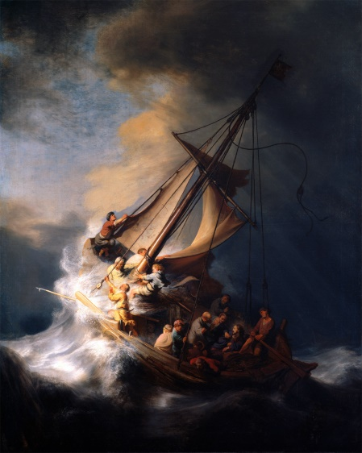
Foundation of Repentance
The Lost Art of
Repentance Part 2
Pastor Mark Schwarzbauer PhD
Family Worship Center 5/1/16

Review of Part One:
Part One: The Foundation of Repentance
- Hebrews 6.
- Repentance. (Easton’s Bible Dictionary)
- Verb and cognate noun metanoia is a change of mind and purpose and life.
- True repentance changes the mind and hates sin.
- True Repentance leads to a change in your lifestyle.
- True repentance grabs ahold of God’s mercy in Jesus.
- O.T. and into John – Repent and “Produce fruit in keeping with repentance.” Matthew 3:8.
- The Message of Jesus – Matthew 4 called people to repent.
- Paul in Acts 17:30 “In the past God overlooked such ignorance, but now he commands all people everywhere to repent.”
- Everyone needs repentance including believers- Rev. 2:5.

Part Two: The Lost Art of Repentance
- The stolen Rembrandt – Something has been stolen from YOU too!
- William Booth who founded the Salvation Army said “The chief danger that confronts the coming century will be religion without the Holy Ghost, Christianity without Christ, forgiveness without repentance, salvation without regeneration, politics without God, heaven without hell.”
- The Lost Art of Repentance.

Part Three: The Beautiful Power of Repentance
- Repentance isn’t negative, although you should feel bad about your sin, repentance leads to great joy and power.
- Empowered through repentance- calling sin what it is… “sin” gives you the power to repent and change. GOOD NEWS!
- Restoring of joy through repentance.
- “Restore to me the joy of your salvation.” Ps 51:12
- Cleansing through repentance changes not only your past but your future!
- Refreshing… Acts 3:19 “Repent, then, and turn to God, so that your sins may be wiped out, that times of refreshing may come from the Lord,”
- II Chronicles 7:14.

End of Review of The Lost Art of Repentance Part 1
The Lost Art of Repentance Part 2

Part Four: Restoration of Personal Responsibility
- Flip Wilson and “Geraldine” The devil made me do it (never accepting responsibility).
- Man at the fall and ever since has deflected responsibility – Adam blamed Eve, Eve blamed the serpent.
- Man developed into blaming something or someone else.
- Comedian Anna Russell in her “Psychiatric Folksong”
I went to my psychiatrist to be psychoanalyzed
To find out why I killed the cat and blacked my husband’s eye.
He laid me on a downy couch to see what he could find,
And here’s what he dredged up, from my subconscious mind.
When I was one, my mummy hid my dolly in a trunk
And so it follows, naturally, that I am always drunk.
When I was two, I saw my father kiss the maid one day,
and that is why I suffer from kleptomania.
At three I had a feeling of ambivalence towards my brothers, and so it follows naturally I poisoned all my lovers. But I am happy now I have learned the lessons this has taught:
Everything I do that’s wrong, is someone else’s fault!
- The new repository for blame… “I’m not guilty, I’m just sick!”
A. Ethan Couch – He had already been on probation for alcohol related offense at age 14. At age 16 he stole 2 cases of beer from Walmart, got drunk to three times the legal limit for adults and driving drunk he killed 4 people and injured 9 others. The defense argued that he had “Affluenza” and therefore wasn’t responsible because he was too rich and spoiled to know right from wrong. Couch got probation and no jail time.
B. President of the American University Richard Berendzen, got caught making obscene phone calls. He blamed it on being a victim of child abuse.
C. Not responsible for stealing because of kleptomania.
D. Not responsible for lying because of being pathological.
E. People now defend their wrong actions on being a victim themselves or sick.
F. It is popular to look for an environmental or obscure medical scapegoat to relieve people of taking any personal responsibility.
G. Culture will continue to develop this to new extremes as people accept less responsibility for themselves.

- Personal responsibility.
A. Romans 14:12 “So then each of us shall give account of himself to God.”
B. We are free moral agents - Joshua 24:15.
C. Our theme in 2015 of “Choosing Your Destiny”.
D. Why I am Not an Atheist- Part Three – Free Will, 7-14-13.
- The Good News is… You really can change.
A. I Corinthians 6:9-11 9 Do you not know that the unrighteous will not inherit the kingdom of God? Do not be deceived. Neither fornicators, nor idolaters, nor adulterers, nor homosexuals, nor sodomites, 10 nor thieves, nor covetous, nor drunkards, nor revilers, nor extortioners will inherit the kingdom of God. 11 And such were some of you. But you were washed, but you were sanctified, but you were justified in the name of the Lord Jesus and by the Spirit of our God.
B. Such WERE some of you - You CAN change.
- Repentance – gives you back the power for real change.
A. There are organic brain diseases and real organic psychological illnesses. However, in absence of true organic brain disorders to call wrong behavior “sickness” instead of what is really is “sin”, cripples the person.
B. You can’t repent of “sickness” but you can repent and overcome “sin.”
- Dr. Hobart Mowrer, professor at Harvard and Yale, past president of American Psychological Association, wrote in the American Psychologist “For several decades we psychologists looked upon the whole matter of sin and moral accountability as a great incubus and acclaimed our liberation from it as epoch making. But at length we have discovered that to be free in this sense, that is, to have the excuse of being sick rather than sinful, is to court the danger of also becoming lost. This danger is, I believe, betokened by the widespread interest in existentialism, which we are presently witnessing. In becoming amoral, ethically neutral and free, we have cut the very roots of our being, lost our deepest sense of selfhood and identity, and with neurotics, themselves, we find ourselves asking, “Who am I, what is my deepest destiny, what does living mean?”
A. Mowrer was an agnostic who had incredible success curing “mental illness” by insisting people “repent.”
B. William Glasser- Reality Therapy, Jay Adam- Competent to Counsel et al.
- Time to repent - face our problems and confess our sins and turn to God for forgiveness and healing.
- Jesus and the cross.
A. Sin has real consequences including hell and separation from God.
B. Jesus took your sin upon himself to set you free. Col. 2. He offers Salvation by His completed work.
C. We are called to “repent and believe” Mark 1:15, Luke 24:47, Acts 2:38, 3:19, 17:30, 20:21, 26:20 et al.
- Communion brings us back to repent and believe.

Closing… Don’t let anyone rob you! Fake police or false shepherds… Repent, recover your joy, be refreshed and live in victory! Communion

Discussion Items and Questions for Home and Small Group
1. In your own words explain what it really means to “repent”.
2. Why do you think people blame others or things instead of accept the responsibility for sin?
3. How does facing “sin” instead of calling it “sickness” empower a person to change?
4. How does God wash, sanctify and justify us?
5. Take time to pray together.

Portions of part four are from the article I’m not guilty, I’m just sick” by Bert Thompson Ph.D. http://apologeticspress.org/apcontent.aspx?category=9&article=1344
“Sin”: The lesser of two evils. Mowrer, O. Hobart, American Psychologist, Vol 15(5), May 1960, 301-304.

