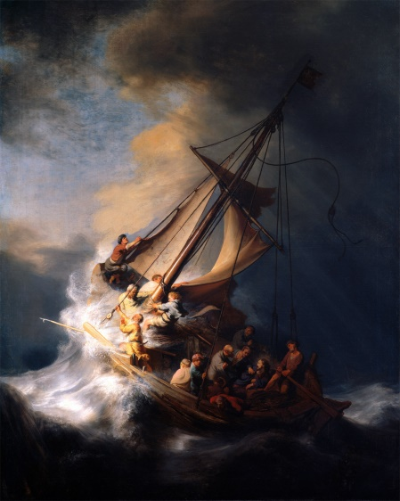
Foundation of Repentance
The Lost Art of
Repentance
Pastor Mark Schwarzbauer PhD
Family Worship Center 4/10/16

Text: Hebrews 6:1-3

Part One: The Foundation of Repentance
- Hebrews 6.
- Moving forward through and past the foundation principles.
- The foundation of repentance from dead works.
- Foundation… what you BUILD on.
- Repentance. (Easton’s Bible Dictionary)
- There are three Greek words used in the New Testament to denote repentance and their meanings have important differences.
- They are all based on “meta” meaning “change afterwards” and “nous” referring to the mind.
- The verb metamelomai is used of a change of mind, such as to produce regret or even remorse on account of sin, but not necessarily a change of heart.
- This word is used with reference to the repentance of Judas (Matt. 27:3).
- II Corinthians 7:10 “Godly sorrow brings repentance that leads to salvation and leaves no regret, but worldly sorrow brings death.”
- Being sorry for being caught, perhaps even sorry for what resulted, perhaps even somewhat sorry for they’ve done; but not sorry enough to want to change.
- The Verb Metanoeo means to change one’s mind and purpose, as the result of acquired knowledge. Used with Metanoia to indicate true repentance.
- Cognate noun metanoia is a change of mind and purpose and life.
- True repentance changes the mind and hates sin.
- True Repentance leads to a change in your lifestyle.
- True repentance grabs ahold of God’s mercy in Jesus.
- The Message of John – Repent and “Produce fruit in keeping with repentance.” Matthew 3:8.
- The Message of Jesus – Matthew 4 called people to repent.
- Paul in Acts 17:30 “In the past God overlooked such ignorance, but now he commands all people everywhere to repent.”

- Everyone needs repentance.
- Rev. 2:5.
- Written to the church in Ephesus and represents us at times too.
- Repentance is to move us back into living how God wants us to live.

Part Two: The Lost Art of Repentance
- The stolen Rembrandt – The Storm on the Sea of Galilee was stolen from the Isabella Stewart Gardner Museum in 1990.
- Something has been stolen from YOU too!
- William Booth who founded the Salvation Army said “The chief danger that confronts the coming century will be religion without the Holy Ghost, Christianity without Christ, forgiveness without repentance, salvation without regeneration, politics without God, heaven without hell.”
- We are now seeing his words fulfilled.
- They are many churches “without the Holy Ghost”.
- Churches that have “Christianity without Christ”.
- “Forgiveness without repentance”.
- “Salvation without regeneration.” (Quoting Eph. 2:8&9 without 10 and ignoring James et al).
- “Politics without God” now is even anti-god!
- “Heaven without hell.”
- The Lost Art of Repentance.

Part Three: The Beautiful Power of Repentance
- Repentance isn’t negative, although you should feel bad about your sin, repentance leads to great joy and power.
- Empowered through repentance- calling sin what it is… “sin” gives you the power to repent and change. GOOD NEWS!
- Restoring of joy through repentance.
- “Restore to me the joy of your salvation.” (Psalm 51:12)
- Cleansing through repentance changes not only your past but your future!
- Refreshing… Acts 3:19 “Repent, then, and turn to God, so that your sins may be wiped out, that times of refreshing may come from the Lord,”
- II Chronicles 7:14.

Closing… Don’t let anyone rob you! Fake police or false shepherds… Repent, recover your joy, be refreshed and live in victory!

Discussion Items and Questions for Home and Small Group
1. In your own words explain what it really means to “repent”.
2. Why do you think it is so important?
3. How do you see the quote from William Booth as being fulfilled today?
4. What good things come out of repentance?
5. Take time to pray together.

