Opening: Testimonies from Foundation of Self Esteem.

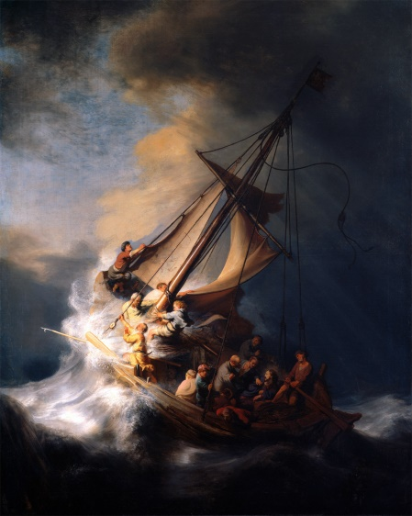
Foundation of Repentance
The Lost Art of
Repentance
Pastor Mark Schwarzbauer PhD
Family Worship Center 4/10/16

Text: Hebrews 6:1-3 “Therefore, leaving the discussion of the elementary principles of Christ, let us go on to perfection, not laying again the foundation of repentance from dead works and of faith toward God, 2 of the doctrine of baptisms, of laying on of hands, of resurrection of the dead, and of eternal judgment. 3 And this we will do if God permits.”

Part One: The Foundation of Repentance
- Hebrews 6.
- Moving forward through and past the foundation principles.
- The foundation of repentance from dead works.
- Foundation… what you BUILD on.

- Repentance.
- There are three Greek words used in the New Testament to denote repentance and meanings have important differences. (Easton’s Bible Dictionary)
- They are all based on “meta” meaning “change afterwards” and “nous” referring to the mind.
- The verb metamelomai is used of a change of mind, such as to produce regret or even remorse on account of sin, but not necessarily a change of heart.
- This word is used with reference to the repentance of Judas (Matt. 27:3).
- II Corinthians 7:10 “Godly sorrow brings repentance that leads to salvation and leaves no regret, but worldly sorrow brings death.”
- Being sorry for being caught, perhaps even sorry for what resulted, perhaps even somewhat sorry for they’ve done; but not sorry enough to want to change.
- The Verb Metanoeo means to change one’s mind and purpose, as the result of acquired knowledge. Used with Metanoia to indicate true repentance.
- Cognate noun metanoia is a change of mind and purpose and life.
- True repentance changes the mind and hates sin.
- True Repentance leads to a change in your lifestyle.
- True repentance grabs hold of God’s mercy in Jesus.
- The Message of John – Repent and “Produce fruit in keeping with repentance.” Matthew 3:8.
- The Message of Jesus – Matthew 4 called people to repent.
- Paul in Acts 17:30 “In the past God overlooked such ignorance, but now he commands all people everywhere to repent.”
- Everyone needs repentance.
- Rev. 2:5 “Consider how far you have fallen! Repent and do the things you did at first. If you do not repent, I will come to you and remove your lampstand from its place.”
- Written to the church in Ephesus and represents us at times too.
- Repentance is to move us back into living how God wants us to live.
Part Two: The Lost Art of Repentance
- The stolen Rembrandt – The Storm on the Sea of Galilee was stolen from the Isabella Stewart Gardner Museum in 1990.
- Thieves disguised as police officers broke into the museum and stole The Storm on the Sea of Galilee and 12 other works.
- The biggest art theft in US history and remains unsolved.
- The museum still displays the paintings' empty frames in their original locations. (https://en.wikipedia.org/wiki/The_Storm_on_the_Sea_of_Galilee)
- Something has been stolen from YOU too!

- William Booth who founded the Salvation Army said “The chief danger that confronts the coming century will be religion without the Holy Ghost, Christianity without Christ, forgiveness without repentance, salvation without regeneration, politics without God, heaven without hell.”
- We are now seeing his words fulfilled.
- They are many churches “without the Holy Ghost”.
- Churches that have “Christianity without Christ”. (As seen in “about” from Hope Church of Christ).
- “Forgiveness without repentance”.
- “Salvation without regeneration.” (Quoting Eph. 2:8&9 without 10 and ignoring James).
- “Politics without God” now is even anti-god!
- “Heaven without hell.”
- The Lost Art of Repentance.

Part Three: The Beautiful Art of Repentance
- Repentance isn’t negative, although you should feel bad about your sin, repentance leads to great joy and power.
- You are Empowered through Repentance- calling sin what it is… “sin” gives you the power to repent and change. GOOD NEWS!
- Restoring of joy through repentance.
- “Restore to me the joy of your salvation.” (Psalm 51:12)
- Cleansing through repentance changes not only your past but your future!
- Refreshing… Acts 3:19 “Repent, then, and turn to God, so that your sins may be wiped out, that times of refreshing may come from the Lord,”
- II Chronicles 7:14 “if My people who are called by My name will humble themselves, and pray and seek My face, and turn from their wicked ways, then I will hear from heaven, and will forgive their sin and heal their land.”

Closing… Don’t let anyone rob you! Fake police or false shepherds… Repent, recover your joy, be refreshed and live in victory!

Discussion Items and Questions for Home and Small Group
1. In your own words explain what it really means to “repent”.
2. Why do you think it is so important?
3. How do you see the quote from William Booth as being fulfilled today?
4. What good things come out of repentance?
5. Take time to pray together.

