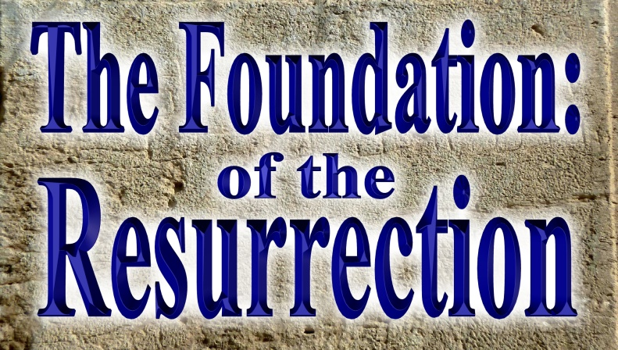
What the Resurrection
Of Jesus Christ
Means in Your Life

Pastor Mark Schwarzbauer PhD
Family Worship Center 3/27/16

Text: I Cor. 15:1-4 ¹Now, brothers and sisters, I want to remind you of the gospel I preached to you, which you received and on which you have taken your stand. ²By this gospel you are saved, if you hold firmly to the word I preached to you. Otherwise, you have believed in vain. ³For what I received I passed on to you as of first importance: that Christ died for our sins according to the Scriptures, ⁴that he was buried, that he was raised on the third day according to the Scriptures,

Part One: What the Resurrection Means to Christianity
- The literal physical resurrection of Jesus Christ is foundational to the church.
- The churches’ teaching of salvation is summarized in Romans 10:8b-9 “…the message concerning faith that we proclaim: If you declare with your mouth, “Jesus is Lord,” and believe in your heart that God raised him from the dead, you will be saved.”
- But Paul tells us there were people in the church denying the resurrection!
- I Corinthians 15:12 “But if it is preached that Christ has been raised from the dead, how can some of you say that there is no resurrection of the dead?”
- Who would deny the resurrection and why?
- Who would deny the resurrection?
- The Sadducees were a powerful social and political force who denied the resurrection (Mark 12:18f, Acts 23:7-9, et al). They started off from the High Priest Zadok and came to represent nobility, wealth and power (Josephus “Ant.” xviii. 1, § 4). But, they degenerated under Hellenistic influence to where they abandoned much of their faith and focused on pleasure in living for the moment. They were the opposing political party of the Pharisees. Instead of believing in a literal Messiah the Sadducees believed in being their own deliverers. Instead of believing in a literal personal resurrection they allegorized it as being a national resurrection. Their influence was popular among the Hellenized areas including Corinth because it focused on immediate pleasure and eliminated future judgment.
- Sadducees today- There are still people in churches today who have degenerated spiritually to the point where they abandon the foundation of the literal resurrection. Why? Because they are focused on this world and living for pleasure in the now. The culture, instead of God’s Word, is their bible.
- Paul challenges the Corinthians to recognize how foolish the personal anti-resurrection belief really is.
- I Corinthians 15:13-19 ¹³If there is no resurrection of the dead, then not even Christ has been raised. ¹⁴And if Christ has not been raised, our preaching is useless and so is your faith. ¹⁵More than that, we are then found to be false witnesses about God, for we have testified about God that he raised Christ from the dead. But he did not raise him if in fact the dead are not raised. ¹⁶For if the dead are not raised, then Christ has not been raised either. ¹⁷And if Christ has not been raised, your faith is futile; you are still in your sins. ¹⁸Then those also who have fallen asleep in Christ are lost. ¹⁹If only for this life we have hope in Christ, we are of all people most to be pitied.”
- If there is no resurrection… 1. Christ isn’t raised, 2. Our preaching is useless, 3. Your faith in useless, 4. We are false witnesses, 5. Your faith is futile, 6. You are still in your sins, 7. The dead in Christ are permanently gone.
- Why they denied the resurrection.
- If there is no resurrection then this life is all there is giving you have a license for vice and sin for total pleasure seeking. No future judgment means no present restraint is required. In Corinth, that sounded really good. Bottom line- it was an excuse to sin.
- I Cor. 15:32-34 ³²If I fought wild beasts in Ephesus with no more than human hopes, what have I gained? If the dead are not raised, “Let us eat and drink, for tomorrow we die.” ³³Do not be misled: “Bad company corrupts good character.” ³⁴Come back to your senses as you ought, and stop sinning; for there are some who are ignorant of God—I say this to your shame.
- The resurrection is real… and will follow with real judgment. John 5:28-29
²⁸“Do not be amazed at this, for a time is coming when all who are in their graves will hear his voice ²⁹and come out—those who have done what is good will rise to live, and those who have done what is evil will rise to be condemned.

Part Two: What the Resurrection Means in Your Life
- I Corinthians 15:1-4 –
- I Cor. 15:1-4 ¹Now, brothers and sisters, I want to remind you of the gospel I preached to you, which you received and on which you have taken your stand. ²By this gospel you are saved, if you hold firmly to the word I preached to you. Otherwise, you have believed in vain. ³For what I received I passed on to you as of first importance: that Christ died for our sins according to the Scriptures, ⁴that he was buried, that he was raised on the third day according to the Scriptures,”
- Your stand – Building Your Foundation.
- Because the resurrection is real, if you hold to the Gospel truth in faith, it means your past is forgiven your present is cared for and your future is assured.

- I Peter 1:3 “Praise be to the God and Father of our Lord Jesus Christ! In his great mercy he has given us new birth into a living hope through the resurrection of Jesus Christ from the dead,”
- The resurrection gives us a “living hope”.
- Same Greek word as John 10:10 LIFE more abundantly.
- Enjoying real life here, with the past forgiven, the future assured and His favor and blessings on you every day!
Closing: I Corinthians 15:58 Therefore, my dear brothers and sisters, stand firm. Let nothing move you. Always give yourselves fully to the work of the Lord, because you know that your labor in the Lord is not in vain.

Discussion Items and Questions for Home and Small Group
- Who had influenced some people in Corinth to deny the resurrection?
- In your own words, what was their reason for denying the resurrection? (Note- I Cor. 15:32-34)
- According to I Peter 1:3, what has God given you through the resurrection of Christ?
- Complete these verses… I Cor. 15:1-4 “¹Now, brothers and sisters, I want to remind you of the gospel I preached to you, which you received and on which you have __________________. ²By this gospel you are saved, if you ___________________ _________ I preached to you. Otherwise, you have believed in vain. ³For what I received I passed on to you as of first importance: that Christ _________________
_______ according to the Scriptures, ⁴that he was ________, that he was _________ the third day according to the Scriptures,”
- In light of I Corinthians 15:58, how will YOU stand firm?

http://www.jewishencyclopedia.com/articles/12989-sadducees

