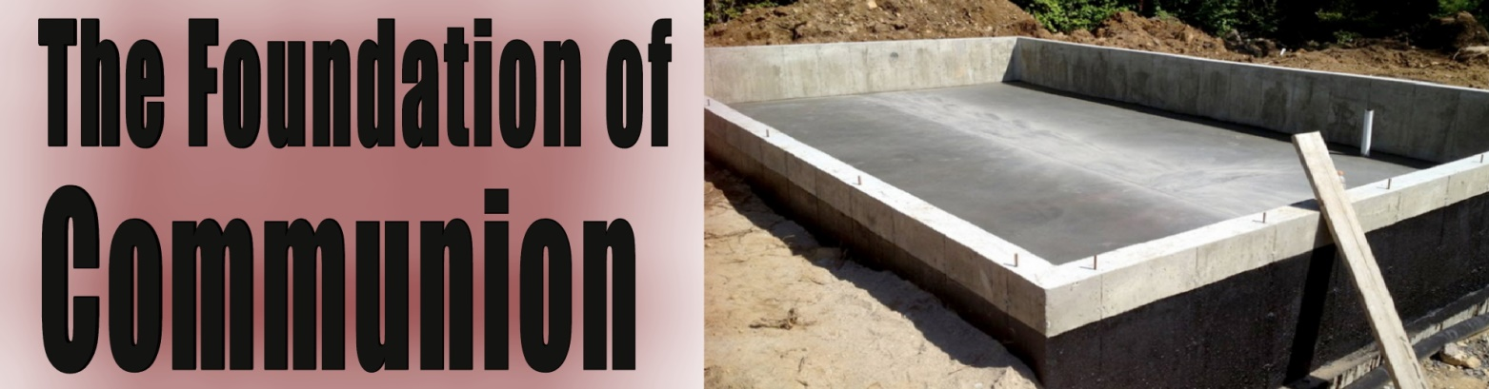
Pastor Mark Schwarzbauer PhD
Family Worship Center 2/14/16

Intro: Today is Valentine’s Day. Of course it is natural to reflect on love today. Communion is the tangible symbol of God’s sacrificial love. In preparation for communion we will look at its foundation in the Old Testament. Consider that The Old Testament is the New concealed, the New Testament is the Old Testament revealed. Communion is an extension of the Passover. It is also a call for exclusive love to have no other gods before Him.

Text: Exodus 12:1-14. Excerpt 12-14 ¹² ‘For I will pass through the land of Egypt on that night, and will strike all the firstborn in the land of Egypt, both man and beast; and against all the gods of Egypt I will execute judgment: I am the Lord. ¹³ Now the blood shall be a sign for you on the houses where you are. And when I see the blood, I will pass over you; and the plague shall not be on you to destroy you when I strike the land of Egypt.
Part One: Foundation of Communion
- The original sin of man.

A. Communion was broken with God.

B. The first sacrifice for covering was made.

C. The price of sin is death and therefore to redeem from sin the requirement is the price of blood as life is in the blood.
- The sacrificial system and Abraham the father of faith.
- Israel was enslaved in Egypt.
- God sent the plagues to judge the gods of Egypt and call the people of Israel back to their first love and exclusive worship of Yahweh, the creator God.
- Exodus 11:1-12:36 ~ The Passover and the death of the first born.
- Judgement against…
- Min the god of reproduction.
- Heqet, a goddess who was to attend women at childbirth.
- Isis who was supposed to protect children.
- Pharaoh's first born son who was supposed to be a god.
- Apis, Nedes and all the gods of Egypt, Exodus 12:12.
- There was no natural explanation.
- Yahwah is seen as the greatest.
- God sets them free to worship Him and establish them in the Promised Land where they can commune with Him.

Part Two: The Symbols of the Passover
- The Exodus from the land and life of sin.
- The Lamb symbolizes Jesus.
- Without blemish (I Peter 1:18-19).
- The blood covered the doorposts so the angel of death “Passed Over.”
- The eating in haste.
- Dressed up and ready to leave.
- Prepared to leave old life behind and follow God.
- Unleavened bread.
- Leaven was a symbol of sin.
- Removing sin from your life and lifestyle (I Corinthians 5:6-8).
- Bitter herbs.
- Symbol of the horrible life of slavery.
- Reckoning life of sin as terrible and abhorrent.
VI. The memorial for life- communion.

Part Three: The Symbols Communion
- Jesus as the Lamb of God who takes away the sin of the world.
- I Corinthians 11:23-26.
- Communion.
- Bread symbolizes His body.
- Cup symbolizes His blood.
- The cup after supper = the third cup.
- Exodus 6:6&7.
- The first cup- I will bring you out.
- The second cup- I will rescue you.
- The third cup (communion) I will redeem you.
- The fourth cup (at the Wedding Feast of the Lamb) I will take you as My people, and I will be your God.

Closing… Communion: The first commandment is given in Exodus 20- You shall have no other gods before Me. God is love and calls for exclusive love and putting Him first.

Discussion Items and Questions for Home and Small Group
1. What does it mean that God wants communion with you?
2. What interferes with your communion with God?
3. How can you improve your communion with God?
4. Pray for each other.

