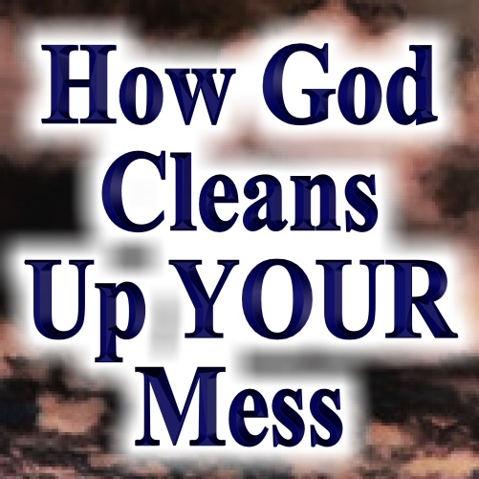
The Foundation
Of the Fall and
Redemption of Man
Pastor Mark Schwarzbauer PhD
Family Worship Center 3/20/16

Introduction: This is Passion Sunday, the first day of Passion Week when Christ suffered for us. We will consider the foundation of the Fall and Redemption of Man.

Text: I Timothy 2:5-6

Part One: The Mess We Made
I. Foundational Truth - Man was created good and upright; for God said, "Let us make man in our own image, after our likeness." However, man by voluntary transgression fell and thereby incurred not only physical death but also spiritual death, which is separation from God.
A. God made man good.
B. Man in voluntary transgression messed it all up.
II. Job 9:33- talking with Bildad he calls for a mediator. “If only there were someone to mediate between us, someone to bring us together,”
III. Our need when we meet ourselves (Isaiah 6:5).
IV. Charlie Peacock ©1991 (also sung by DC Talk) “I keep trying to find a life, on my own apart from You. I am the king of excuses, I've got one for every selfish thing I do. What's going on inside of me? I despise my own behavior. This only serves to confirm my suspicions that I'm still a man in need of a Savior.”
V. Foundational Truth - Man's only hope of redemption is through the shed blood of Jesus Christ the Son of God.

Part Two: The Mediator Who Cleans Up
I. The Mediator.
  From the Greek Word μεσίτης (
  Meaning a go–between (from  middle, and  to go).
- One who mediates between two parties with a view to producing peace.
- Idiomatically, ‘one who stands in the middle’, ‘one who speaks to both’, or ‘one who causes arguments to cease.’
II. I Timothy 2:5-6. “For there is one God and one Mediator between God and men, the Man Christ Jesus, ⁶who gave Himself a ransom for all, to be testified in due time.”
- There is only one Mediator representing God to us and us to God.
- He is more than a mere mediator.
  - The Word became flesh and dwelt among us, John 1:14.
  - Only by possessing both deity and humanity could He represent claims of the one and relate to the needs of the other.
III. Hebrews 9:14-15. “14 how much more shall the blood of Christ, who through the eternal Spirit offered Himself without spot to God, cleanse your conscience from dead works to serve the living God? 15 And for this reason He is the Mediator of the new covenant, by means of death, for the redemption of the transgressions under the first covenant, that those who are called may receive the promise of the eternal inheritance.”
- The mediator who offered His own blood.
- How God Cleans Up Your Mess.
- Dead works won’t save you.
- Your redemption from sin and suffering by a savior.
- Your redemption to serve the living God.
- Your redemption for eternal life.

Part Three: The Missing Savior
I. The missing puzzle piece.
II. Pascal’s God-shaped vacuum.
III. The story of the prince and the poor man’s bride.

Closing: Are you missing a savior in your life?

Discussion Items and Questions for Home and Small Group
1. What evidence do you see that reveals man is lost in sin?
2. Why do you think we need a savior?
3. How is Jesus uniquely qualified to be the mediator between God and Man?
4. Christ made the necessary sacrifice for man’s redemption. What remains necessary for that redemption to take place?
5. Pray for each other.

Ravi Zacharias Story
In 1974, a few weeks before Cambodia fell, I was preaching in Phnom Penh. I remember going to see a play. In the play a prince had stolen the wife of a peasant who was newly married. The prince refused to give her back and then told the woman that if she said this man was her husband, he would kill the husband in front of her.

When the peasant went to the king asking that the prince return the wife, the king said, "Let's call her in and ask her." She comes in and says, "That man is not my husband. The prince is my husband." The peasant is dismayed.

A priest jumps into the middle and says, "Your honor, I have a medicine that when both men drink it they will have to tell the truth."

Both of them drank it. Then he said, "Since one of you is going to die, each of you may spend five minutes alone with the girl."

They hung a huge barrel on a rod, and they were to hold each end of the rod and not to have any contact. One was going to hold one end of the rod, the other the other end of the rod, and the barrel was to be in the middle.

The peasant holds one end, the woman the other. The woman says, "Please forgive me. The only reason I said what I did is I'm trying to save your life."

Then the prince spends five minutes with her. He says, "If you say that man is your husband, we'll kill you and him."

Then the magic of it all: the barrel opens, and a little boy jumps out. He's been writing down the conversations. The medicine was only a decoy. The boy gives the conversations to the priest who says, "King, your son is a liar. This peasant is telling the truth."

The whole thing explodes into confusion with the king killing everyone and the girl committing suicide.

I was ready to celebrate until the end. Then I said to my non-Christian interpreter, "What was missing in that play?"

He said, "Mr. Zacharias, what was missing in that play was a savior, somebody to take up the cause of the needy."

Louw, Johannes P. and Nida, Eugene A., Greek-English Lexicon of the New Testament based on Semantic Domains, (New York: United Bible Societies) 1988, 1989.

