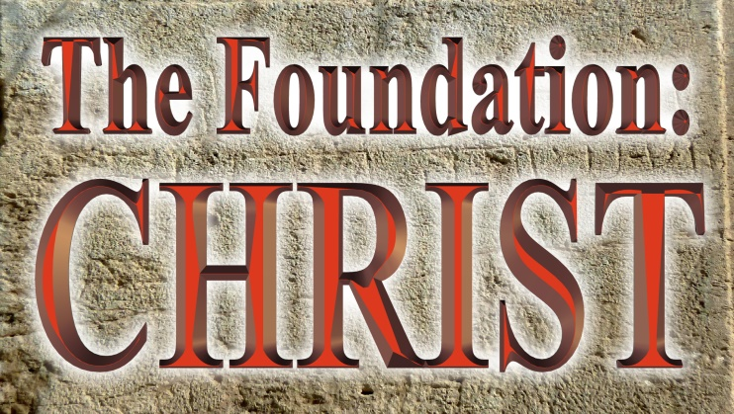
Pastor Mark Schwarzbauer PhD
Family Worship Center 3/13/16

Part One: The Foundation Attacked
- Partial Review of “The Foundation GOD” 2/28/16 (5 minutes- Part One).
- We go from Genesis 1 to Genesis 2 & 3.
A. Man is created good.
B. Man chooses sin.
C. God promises a redeemer who will crush the head of the serpent. Gen. 3:15.
D. Ever since that the serpent has tried everything to distort, defame and bring rejection of the promised redeemer.
- Attacking the promised redeemer- Jesus, The Christ.
A. When the Christ was born the devil used Herod to try and kill the child – Matthew 2.
B. In the temptations the devil tried to throw Jesus off track. Of course, the devil was unsuccessful at throwing Jesus off track of securing your redemption so the devil has taken to throwing people off track of Jesus.
B. Jehovah’s Witnesses teach that Jesus is not God but instead was created as Michael the Archangel and became a “lessor god”.
C. Mormons teach Jesus was not the eternal God but was born as the first and greatest spirit child of the heavenly father and mother who were once like us, and that Lucifer, the devil, was Jesus’ brother.
D. New Agers claim Jesus was just an enlightened master and not God.
E. Unitarian Universalists claim Jesus was just a good moral teacher.
- The Cornerstone.
A. Psalm 118:22-23 “The stone which the builders rejected Has become the chief cornerstone. ²³This was the Lord’s doing; It is marvelous in our eyes.”
B. Many Jews rejected their very own Messiah. John 1:11, 12.
- If you want to destroy something you destroy the foundation.
A. Attacking the foundation to make a house crumble.
B. Putting out a fire you don’t extinguish the flames but the source.
- Don’t pass over this too quick! Isaiah 28:16 So this is what the Sovereign LORD says: “See, I lay a stone in Zion, a tested stone, a precious cornerstone for a sure foundation; the one who trusts will never be dismayed.
Part Two: The Foundation CHRIST
- There is a false teaching that Jesus never claimed to be God.
- The Amazing claim to be “the Son of God.” Luke 22:66-71
- They recognized the phrase “the Son of man will sit on the right hand of the power of God” represented the ultimate power and authority of God.
- Jesus was claiming effectual deity (also seen in His forgiving sin Matt. 9).
- The direct question… “Are you then the Son of God?”
- Jesus answers back “You rightly say that I am.”
- Jesus was claiming essential deity.
- The Amazing Implication…
- John 10:33 ³³ The Jews answered Him, saying, “For a good work we do not stone You, but for blasphemy, and because You, being a Man, make Yourself God.”
- The Jews fully understood the implication.
- Not only did He clearly claim to be God in the flesh, He specifically stated that He was the ONLY way to get to heaven, John 14:6.

- The Amazing Incarnation.
- Immanuel – “God with us.” Matthew 1:23, from Isaiah 7:14.
- John 1:1 God was the Word.
- John 8:58… I AM- Exodus 3:14.
- John 14:8-9 “he who has seen Me has seen the Father.”
- John 20:28 Thomas proclaims… “my Lord and my God”. Jesus accepts worship.
- Colossians 2:9 “the fullness of the godhead bodily.”
- Revelation- Alpha and Omega, EMET.
1. Isaiah 44:6, LORD = YAHWAH First and last. Besides me there is no God.
2. Revelation 1:8, Alpha and Omega, Beginning & End, ALMIGHTY.
3. Rev. 1:11- Alpha and Omega, First and Last.
4. Rev. 1:17-18 First and Last, WHO died! (Jesus is the one who died!).
5. These are the words of Jesus claiming clearly to be YAHWAY GOD.
- For Additional Study
A. https://irr.org/ Institute for Religious Research, Investigating today’s religious claims in light of history, science and the Bible. IRR investigates Mormonism and Jehovah’s Witnesses along with other religions.
B. Videos along with PowerPoints are available from http://i-fwc.com/Media/archive.html covering “The Truth about Jehovah’s Witnesses”

Part Three: Your Foundation ~ CHRIST
- John 5:39-40 “ 39 You search the Scriptures, for in them you think you have eternal life; and these are they which testify of Me. 40 But you are not willing to come to Me that you may have life.”
- Don’t let anyone undermine your foundation of who Jesus Christ really is.

Closing -Jesus is God who put it all together and in the end will judge everyone. John 5:22. Are you ready?

Discussion Items for Home and Small Group-
1. In your own Words, why would the devil want to prevent people from knowing who Jesus really is?
2. Which Bible verses helped you best understand that Jesus is God?
3. Why does it matter?
4. Pray for each other.

