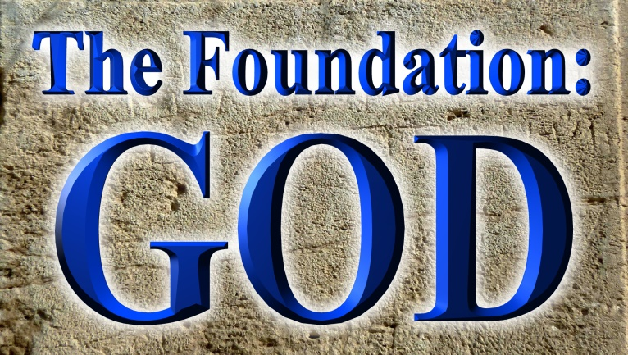
Pastor Mark Schwarzbauer PhD
Family Worship Center 2/28/16

Genesis 1:1-5 1 In the beginning God created the heavens and the earth. 2 The earth was without form, and void; and darkness was on the face of the deep. And the Spirit of God was hovering over the face of the waters.
3 Then God said, “Let there be light”; and there was light. 4 And God saw the light, that it was good; and God divided the light from the darkness. 5 God called the light Day, and the darkness He called Night. So the evening and the morning were the first day.

Part One: The Foundation- GOD
- Getting to know the Real God.
- Genesis 1:1 In the Beginning GOD.
A. He was Creator Elohim.
B. He was already there when the universe began.
- Genesis 1:2 And the Spirit of God… Ruah vs. 2.
- Genesis 1:3 He spoke and it came into being...
A. SAID – note He SPOKE and the WORD in John 1:1-3 “In the beginning was the Word, and the Word was with God, and the Word was God. 2 He was in the beginning with God. 3 All things were made through Him, and without Him nothing was made that was made.”
B. In Genesis Chapter One verses 1,2 and 3 we begin with three persons of the Godhead.
C. The foundation of who He is, God the Father, the Spirit, The WORD (Jesus).
D. The foundation of everything.
- God saw that it was GOOD… emanated from Him who is good- James 1:17 Foundation of WHAT He is.
- God said let US make man in OUR image vs. 26.
A. “Elohim” is plural of “Eloah”, “im” makes it a masculine plural noun.
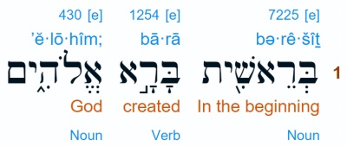
B.
http://biblehub.com/interlinear/genesis/1.htm

C. Let US make man in OUR image.
1. Some try to say God was talking to the angels, but angels didn’t create anything… vs. 1 told us Elohim created it.
2. The infinite God is revealing Himself to our finite understanding.
3. The US and OUR we understand as Father, Son and Holy Spirit.
- In the very first chapter God reveals Himself as triune tri (three) une (unity) (one God eternally existent in 3 persons) (not triplex NOT 3 Gods).
- One God and Deuteronomy 6:4 The Shema
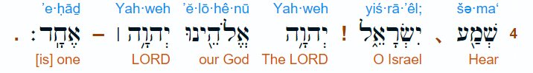
- Deut 6:4

- The Jews will recite Adonai (Lord) instead of saying Yahweh (LORD)
- Yahweh is the holy name of God from the tetra gammon.
- 4 aspirate (breathing) consonants. Every breath you speak the creators name who gave you your breath. When you can no longer speak His name… you die.
- The Lord our God is One.
1. In Hebrew “yachid” means “absolute one.”
2. Hebrew “echad” means “united one.”
3. “Hear O Israel, the Lord our God, the Lord is One” – the word here for “one” is “echad” meaning not an “absolute one” but a “united one”.
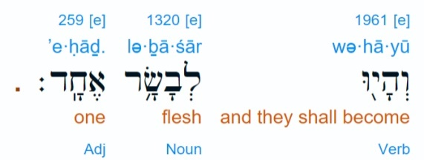
4. NOTE LITERARY CONTEXT- Genesis 2:24- and they shall be one flesh (“echad”)
- http://www.hebrew4christians.com/Scripture/Torah/The_Shema/the_shema.html

- He clearly states there is NO other God PERIOD.
A. Isaiah 43:10-11 “You are My witnesses,” says the Lord, “And My servant whom I have chosen, That you may know and believe Me, And understand that I am He. Before Me there was no God formed, Nor shall there be after Me.
11 I, even I, am the Lord, And besides Me there is no savior.
B. Isaiah 44:6,8b “Thus says the Lord, the King of Israel, And his Redeemer, the Lord of hosts: ‘I am the First and I am the Last; Besides Me there is no God.
8b Is there a God besides Me? Indeed there is no other Rock; I know not one.’”

Part Two: The God of Your Foundation
- Having an accurate and clear understanding of who God is remains essential to developing a real relationship with Him.
- Genesis 1:1-5.
- He is YOUR creator (you are special and He knows what is best for you). Vs. 1.
- When you are without form and void experiencing darkness in your depth… you may feel God is far away. BUT the Spirit of God is right there for you. Vs. 2.
- When God speaks light comes… and you need His Word every day to bring light into your life. Vs. 3.

- God created it all good. Man is the one under the influence of the devil who messes it up. God isn’t the one to blame. He is the One to turn to for fixing it and you. Vs.4.

Closing… Hopefully you better understand in your finite mind. You understand even better when you allow the Holy Spirit to witness to your heart as a believer.

Discussion Items and Questions for Home and Small Group.
1. If you have any questions or concerns on how cults such as Mormons or Jehovah’s Witnesses distort the Scriptures please watch the videos referenced in “Additional Study”.
2. How has today’s message helped you better understand God?
3. Which of the Scriptures shared touched you the most and why?
4. How would you now explain God to someone?
5. Pray for each other.

Additional Study
1. https://irr.org/ Institute for Religious Research, Investigating today’s religious claims in light of history, science and the Bible. IRR investigates Mormonism and Jehovah’s Witnesses along with other religions.
2. Videos along with PowerPoints are available from http://i-fwc.com/Media/archive.html covering “The Truth about Jehovah’s Witnesses” and “The Maze of Mormonism.”
3. Mormons in Transition (50,000 per year leaving LDS).

Yahweh is the more proper pronunciation of God’s name from the Hebrew tetragrammation (four letters) YHWH. During the writing of the Bible, Hebrew did not have vowels as we know them. In respect for the 2nd commandment, the Jews would say Adonai, meaning “Lord” instead of pronounce the holy name of God, YHWH. In about 700 A.D. the Masoretes added modern vowels to the Hebrew Language. They used the vowels for Adonai over the YHWH to remind them to not speak the holy name. The name “Jehovah” is a Latinized version that occurred much later around the 13-16th centuries as a result of mistaking the vowels of Adonai as being part of YHWH.
http://mit.irr.org/28-biblical-passages-which-explicitly-teach-there-only-one-god
http://www.pbs.org/wnet/religionandethics/2015/06/26/june-26-2015-former-mormons/26293/

