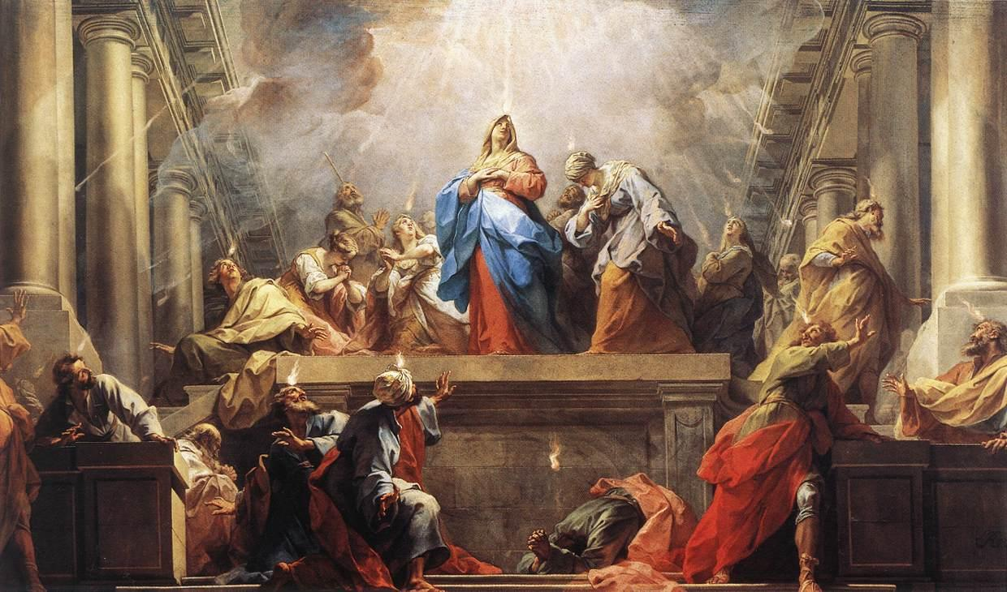
Questions on
The Holy Spirit’s Gift of Speaking in Tongues

Intro: Jack Hayford’s Book “The Beauty of Spiritual Language” he debunks some of the common myths about the Biblical gift of Speaking in Tongues. I encourage everyone to read it. Today I will share from God’s Word answers to some of your questions on this subject.

Text: I Corinthians 14:18 “I thank my God I speak with tongues more than you all;”

Question One: Sometimes when I hear someone speaking in tongues it doesn’t seem like a real language. Are tongues always a real language?

- I Corinthians 13:1 Though I speak with the tongues of men and of angels, but have not love, I have become sounding brass or a clanging cymbal.
- Yes, Tongues are real languages and may be an earthly or a heavenly language.
- What may not seem real to you may be a heavenly language.
- I Corinthians 14:10 “There are, it may be, so many kinds of languages in the world, and none of them is without significance.”
- So many kinds of languages.
- Pawnee - spoken by Native Americans indigenous to Nebraska. Their alphabet is simple—only nine consonants and eight vowels—but they have multiple words that contain more than 30 syllables.
- The Silbo language of La Gomera on the coast of Spain is a language comprised of whistle sounds.
- The South African Xhosa language has nearly 8 million speakers. 18 of the recognized consonants are actually clicking sounds.
- The Pirahã language of Brazil is probably the simplest language in existence, with somewhere between ten and twelve sounds.
- Taa language has 164 consonants, and at least 111 of those are click sounds.
- My experience in Ghana with Ashanti- sounded like babbling gibberish. Not at all real.
- None is without significance – I Cor. 14:10.
- The lesson – It may not sound like a language at all. But as the Holy Spirit gives earthly or heavenly languages they have significance and meaning.

Question Two: When you pray or sing in tongues, do you need to interpret it?

- The question is based on confusion over a message in tongues vs. personal prayer or singing in tongues for worship.
- Understand that speaking in tongues for a message in a church service is the same in essence as the gift of tongues that accompanies the Baptism in the Holy Spirit. (1 Corinthians 12:4-10,28), but different in purpose and use.
- I Corinthians 14:13 tells us that in the church service “Therefore let him who speaks in a tongue pray that he may interpret.”
- The purpose of interpretation is for the whole church to understand and be edified or built up. So any message in tongues must be interpreted. I Cor. 14:28.
- However, praying in the Spirit (in tongues) and singing in the Spirit (in tongues) is for personal prayer and worship. These do not need to be interpreted if they are not given as a message.

Question Three: I haven’t heard much about singing in tongues. Can you address it?

- Singing in tongues is spoken about in I Corinthians 14:15 “What is the conclusion then? I will pray with the spirit, and I will also pray with the understanding. I will sing with the spirit, and I will also sing with the understanding.”
- Once again, this can be done as a message or as personal prayer or individual or corporate worship.
- Based on Hebrew worship TEHILLAH – to sing and to laud, it is a spontaneous singing of random worship to God from your heart. A melodious chant that God inhabits.
- I encourage people to follow I Cor. 14:15 and also sing in the Spirit.

Closing: Once again, you need to start with repenting and believing the Gospel. Then you will receive the Spirit within you. A precious subsequent experience we should all seek is the Baptism in the Holy Spirit with the initial physical evidence of speaking in another tongue. Then, walk in the Spirit. Pray and sing in the Spirit. Don’t quench the Spirit. Release.

Discussion Items for Home and Small Group
- Share one thing you learned from today’s message.
- In your own words, answer question one or two.
- If you have been baptized in the Holy Spirit and speak in tongues, please follow God’s Word and exercise your gift. If you have not been baptized in the Holy Spirit yet, please continue to pray for the blessing.

Retrieved 6/29/17 from http://listverse.com/2013/04/07/10-bizarre-languages-still-spoken-around-the-world/
http://enrichmentjournal.ag.org/201404/201404_013_05_Tongues_pt1.cfm

