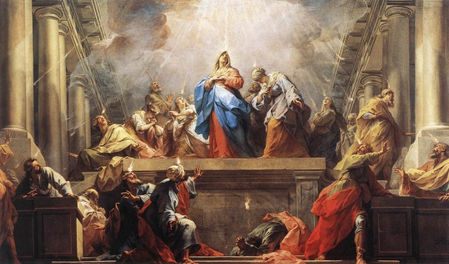
Pentecost 102 Q&A
Family Worship Center August 29, 2010 Rev. Mark Schwarzbauer, Ph.D.

Text: Acts 2:1-4
Introduction: I love questions. I want you to be thinking people. Don’t be cynical and skeptical, but be sincere and searching. Today I will be answering a few of your questions and hopefully generating more. I will also be taking time after service to pray for people to receive the “release” or Baptism in the Holy Spirit. If you did not view/listen to “Pentecost 101” it is essential to the context of today’s message you do so. If you need a DVD David will be happy to get you one. SHORT REVIEW OF 101

Question One: Do all speak with tongues???
Question: “ I speak in tongues and believe in this gift. 1Cor 12 seems to explain the giving of this gift pretty plainly. Verse 11 states that the Holy Spirit distributes to each one individually as HE wills. He goes on to describe the differing parts of the physical body as a way to help us understand how these differing gifts are to work together in harmony. In 12:27-30 he affirms our individuality and asks "...Do all have gifts of healings? Do all speak with tongues? Do all interpret? Seems to beg the answer NO, the Spirit does the distributing at His will. Years ago i heard a sermon stating that this was meant to promote order during church services but I can not find this in context. If we are to believe that speaking in tongues is somehow "required" as proof of being filled with the Holy Spirit or the Holy Spirit being "released" in us, this seems to be saying that unless you speak in tongues you are not filled, or being filled by the Holy Spirit or that the Holy Spirit's power cannot be released in a person. Please comment next Sunday and or via email to help clarify my thoughts on this. I do not want to be or stay in error in my thinking. I would think that possibly others also have similar thoughts or questions.”
I. The “gift of tongues” is the same in essence in Acts and Corinthians but differs in use and purpose.
- The 1st use of the gift of tongues is as initial physical evidence of the Baptism of the Holy Spirit (or “release” as Dennis Bennett prefers to use).
- Acts 2,8,9,10,19.
- The initial physical evidence always present as we covered last week and I will answer further in the next question.
- The 2nd use of the gift of tongues is as a ministry gift used in the church service to give a message.
- The context of I Cor. 12:11 starts in I Cor. 11:18… “when you come together as a church”, and is reinforced as the church meeting in language of I Cor. 12:12… “the body.”
- The 9 gifts of the Spirit presented in I Cor. 12:8-10…
- Three that reveal something.
1). Word of Knowledge. 2). Word of Wisdom. 3). Discerning of Spirits.
b. Three that do something.
1). Faith. 2). Miracles. 3). Healings.
c. Three that say something.
1). Prophecy. 2). Tongues. 3). Interpretation.
3. Tongues as ministry gift in the church service… (I Cor. 14).
a. Gives a message from God (I Cor. 14).
b. A public message must be accompanied by an interpretation for everyone to be edified.
c. Limited to 2 or 3 to present out of balance with other gifts due to zealousness.
- The 3rd use of the gift of tongues as used as a personal prayer language. (I Cor. 14:14-15, Rm8:26)
- The 4th use of the gift of tongues is to worship or “sing in the spirit.” (I Cor. 14:14-15)
II. Don’t misapply the context of the gifts in a church service to the experience of the Baptism of the Holy Spirit.
- Context, Context, Context. B. Literary context
C. The sitz em leben. D. The sitz em glauben.
- Answer: Not all speak with tongues in the church service but all do as initial physical evidence of the Baptism of the Holy Spirit.

Question Two: But my experience is I received the Baptism without Tongues…
Question… My experience, and some others I know, think we received the Baptism of the Holy Spirit but we didn’t speak in tongues. Isn’t my experience as valid as another persons?
I. At first this seems like a totally valid argument…. But stop and analyze it.
- That is making our experience the authority instead of God’s Word.
- That is interpreting the Bible by your experience instead of interpreting your experience by the Bible ~ you make yourself the authority instead of God’s Word.
- This is how false teaching and false doctrine arises.
- Recent examples of Jay Bakker and Oprah.
- Classic example Joseph Smith and others.
- Modern charismatic error of allowing experience to be authority.
- The Bible is our sole rule of Faith and Practice.
- As Martin Luther said… Solo Scriptura.
- Otherwise everyone does what is right in their own eyes (the sin in the Book of Judges).
- II Timothy 3:16-17 ¹⁶﻿All Scripture is given by inspiration of God, and is profitable for doctrine, for reproof, for correction, for instruction in righteousness, ¹⁷﻿that the man of God may be complete, thoroughly equipped for every good work.
II. God’s Word teaches that speaking in tongues is the initial physical evidence.
- Last week in Pentecost 101 we covered Acts 2,8,9,10,19.
- The one common denominator.
- Initial (always the first but not the only) Physical (there are also spiritual ones to follow).
- Dennis Bennett warned about the people making this mistake when the charismatic movement started.
- Your experience with the Holy Spirit was no doubt special, edifying, an anointing or “filling” but it was not the Baptism in the Holy Spirit according the Bible.

Question Three: Why is tongues the initial physical evidence, isn’t that the least of the gifts?
Question: Why would God use the gift of tongues as the initial physical evidence when the Bible says tongues is the least of the gifts?
I. First, go back to the context of the statement… “tongues is the least.”
A. There is nowhere it says “tongues is the least of the gifts”; this is a misnomer from wrongly interpreting I Cor. 12:28 ~ Theory- mentioned last so least/unness
B. Consider I Cor. 13:13 where love is mentioned last, is love therefore the least?
C. Tongues in mentioned first in I Cor. 13 so by that standard it is greatest gift.
D. Self control is the last fruit of the Spirit mentioned (Galatians 5:22-23)… the flawed logic of those who promote tongues as the least and therefore imply it is unnecessary means self control is the least and therefore unnecessary!
1. Test and retest validity.
2. Consistency.
E. The value of tongues is in edification.
1. In the church service use it requires interpretation to edify (I Cor. 14).
2. When accompanied by interpretation it is equal to prophecy (I Cor. 14:5).
II. One reason God chose tongues is James 3:2-10.
- The tongue is like a rudder and turns you.
- The tongue is like a fire destroying you and others.
- The tongue is an unruly evil full of poison.
- No man can tame the tongue- you need God’s help here.
- In the Baptism in the Holy Spirit you yield your tongue to God.
III. God uses tongues to edify and build you up.
- I Cor. 14:4 you edify yourself ~ build yourself up.
- Pray God’s perfect will ~ Romans 8:26. ²⁶﻿Likewise the Spirit also helps in our weaknesses. For we do not know what we should pray for as we ought, but the Spirit Himself makes intercession for us with groanings which cannot be uttered.
- This is why Paul says “I thank my God I speak in tongues more than all of you!” (I Cor. 14:18).

Following church I will be praying for people to receive the Baptism of the Holy Spirit.

Closing- Be open to the person and work of the Holy Spirit.
Questions and Discussion Items for Home and Small Groups
1. Explain the four different uses of tongues.
2. Why is it essential to interpret our experiences by the Bible and not the Bible by our experiences?
3. Explain why God would use tongues as the initial physical evidence.

