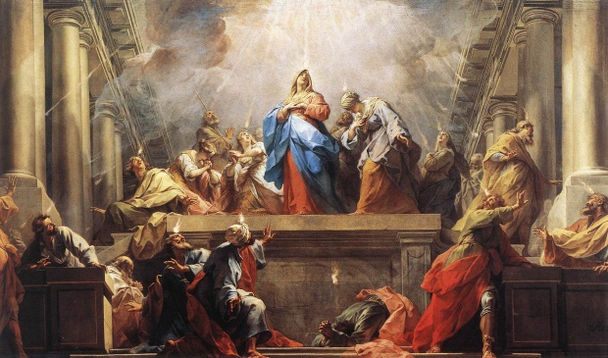
Pentecost 101
Family Worship Center 6/22/14
Rev. Mark Schwarzbauer, Ph.D.
Pentecost, by Jean Restout 1732
Text: Acts 2:1-4
Objectives:
- Identify the four cardinal doctrines of Pentecostalism.
- Consider how they are essential to the church's core mission of reaching the world for Christ.

Introduction: Pentecostalism
I. Pentecostals (aka charismatics, Full Gospel Believers).
- Pentecostals- distinctive of Baptism in Holy Spirit.
  - Distinctive not focus- truly believe the whole Bible, but focus is on Christ not gifts.
  - Throughout the centuries the Baptism of the Holy Spirit was recorded as occurring in monasteries (where there was writing and therefore documentation) even in dark ages.
    - John Wesley-founder Methodist church … “It does not appear that these extraordinary gifts of the Holy Ghost were common in the church for more than two or three centuries. We seldom hear of them after that fatal period when the Emperor Constantine called himself a Christian, and from a vain imagination of promoting the Christian cause, thereby heaped riches and power and honour upon the Christians in general, but in particular upon Christian clergy. From this time, they almost totally ceased; very few instances of the kind being found. The cause of this was not, as has been vulgarly supposed, because there is no more occasion for them because all the world were become Christian. This is a miserable mistake, not a twentieth part of it was then nominally Christian. The real cause was: the love of many, almost all Christians, so called, was waxed cold. The Christians had no more of the Spirit of Christ than the other heathen; the Son of Man when He came to examine His Church could hardly find faith. This was the real cause why the extraordinary gifts of the Holy Ghost were no longer to be found in the Christian Church; because the Christians were turned heathen again, and had only a dead form left ... The grand reason why the miraculous gifts were so soon withdrawn was not that faith and holiness were well-nigh lost, but that dry, formal, orthodox men began even then to ridicule whatever gifts they had not themselves, and to decry them all as either madness or impostures.”
    - Luther (1483-1546) was Baptized in the Holy Spirit and spoke with tongues.
    - The Quakers (1650)
    - D.L. Moody (1882) preached it regularly.
  - Revivals of 1700-1800s, Wesley and the holiness movement.
  - Azusa St. 1906, William Seymour.
    - Son of slaves.
    - Grew up Methodist, Catholic and Baptist.
    - At Parham’s bible college.
    - Invited to preach at Nazarene church in L.A.
    - Preached on Baptism of the Holy Spirit (they didn’t like message & locked him out).
    - He preached at home and Azusa St. mission.
    - Women and blacks both included in a time when neither could vote.
    - Racial walls came down as revival broke out with the Baptism of the Holy Spirit.
  - 1914 A/G formed.
  - 1959- Charismatic movement starts when Episcopal priest Dennis Bennett announces that he speaks with tongues on Easter Sunday.
  - 1967- Roman Catholic Charismatic movement begins in Pittsburgh.
- In all denominations and many waves.
- Largest protestant group in the world.
  - There were 631 million Pentecostals in 2014 comprising nearly 1/4 of all Christians.
  - There were only 63 million Pentecostals in 1970, and the number is expected to reach 800 million by 2025. Some estimates say by 2040 well over a billion will be Pentecostals.
- A/G Largest protestant church in other countries like Brazil and growing fast.
  - A/G now 100 years old.
  - Latino adherents make up 20 percent of the Fellowship.
  - More than 40 percent of total adherents are ethnic minorities and Millennials (ages 18-34), who contributed 21 percent of the growth from 2001-2013.
  - “The rapid growth of the church in the global world, along with the corresponding decline of the church in the global north, suggests that Pentecostalism will account for an ever larger percentage of Christianity in the future.” CT

II. The Jewish Feast of Pentecost.
- Also called the Feast of Weeks (Hebrew Shavuot).
- In Exodus 23:16 it was referred to as the “Feast of Harvest.”
- The Harvest Celebration- Yom Habikkurim, or “the Day of the First Fruits.”
III. New Testament Pentecost.
A. Acts 2:1-42 and B. The fulfillment of Joel 2:8-32.
C. Memorializes giving of the Ruach HaKodesh.
- The Baptism of the Holy Spirit.
- The first fruits harvest of souls.
IV. Pentecostal Doctrine (of the A/G the largest Pentecostal group in the world).
- Same cardinal doctrines as orthodox Christianity.
  - God- Trinity.
  - The deity of Christ.
  - The atoning work of Christ on the cross.
  - The bodily resurrection.
  - The fallen nature of man.
  - Salvation by grace through faith.
- Assemblies of God distinctives, which we consider essential to the church's core mission of reaching the world for Christ.
  - Salvation.
  - The baptism in the Holy Spirit.
  - Divine healing.
  - The second coming of Christ.
Part One: Salvation- Our Purpose
- Man is truly lost without God.
- Romans 3:23.
- Romans 6:23.

Part Two: The Baptism in the Holy Spirit- Our Power
- The normal experience of everyone in the early church.
- This experience is distinct from and subsequent to the experience of the new birth.
A. You already have the Holy Spirit within you at new birth.
B. The baptism is an immersion in power.
- The initial physical evidence of speaking with other tongues.
- The experience of Pentecost.
A. Acts 2:1-4f.
B. Acts 8:9-25, 9:17 (consider I Cor.14:18), 10:44-48, 19:1-6.

Part Three: The Divine Healing-Our Privilege
- Not faith healing but divine healing.
- Divine healing is an integral part of the gospel.
- Deliverance from sickness is provided for in the atonement, and is the privilege of all believers.
A. Isaiah 53:4-5.
B. Matthew 8:16-17.

Part Four: The Second Coming of Christ- Our Prospect
I. The second coming of Christ includes the rapture of the saints, which is our blessed hope, followed by the visible return of Christ with His saints to reign on earth for one thousand years.
II. Motivation to win the lost.

Closing- Be open to the person and work of the Holy Spirit.

Questions and Discussion Items for Home and Small Groups
1. What is the connection between the Feast of Pentecost and the Pentecostal movement?
2. Why is it important the A/G has the same cardinal doctrines as orthodox Christianity?
3. Explain the four distinctives of the Pentecostal movement in your own words.
4. Why is it important to be open to the person and work of the Holy Spirit?
5. Take time to pray for the Holy Spirit to work in your life.

The Works of the Reverend John Wesley, A.M. 1840, pg 266.
Theodor Sauer, Geschichte der Christlichen Kirche ('History of the Christian Church') für Schule und Haus. Rudolf Kuntze's Verlagsbuchandlung, Dresden (1859), p. 400.
http://marccortez.com/2014/04/16/growth-global-pentecostalism-wheaton-theology-conference-4/
http://juicyecumenism.com/2014/06/17/a-growing-u-s-denomination/
http://www.christianitytoday.com/edstetzer/2013/october/charismatic-renewal-movement.html?paging=off

