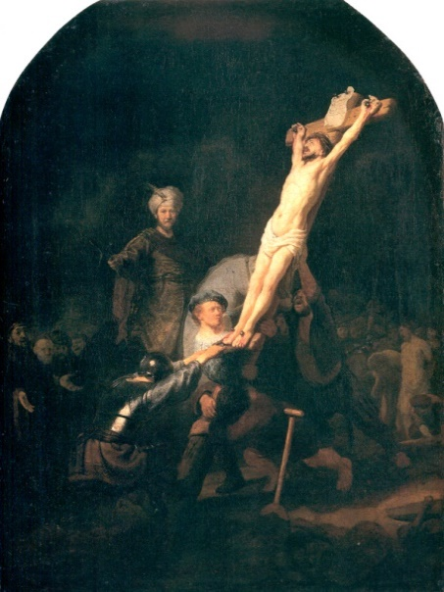
Nailing Your Stuff

to the Cross
Pastor Mark Schwarzbauer, Ph.D.
Family Worship Center 6/12/16

Text: Colossians 2:13-14 ¹³ And you, being dead in your trespasses and the uncircumcision of your flesh, He has made alive together with Him, having forgiven you all trespasses, ¹⁴ having wiped out the handwriting of requirements that was against us, which was contrary to us. And He has taken it out of the way, having nailed it to the cross.

Intro: There is a place of incredible life changing power… the cross, where death purchased life.

Part One: The Wounds from the Cross
- The Crucifixion where Rembrandt painted himself at foot of the cross.
A. Recognizing Jesus was doing this for him.
- Placing ourselves at the cross.
- The wounds of the crucifixion shown to Thomas.

- The picture of Dorian Gray by Oscar Wilde.
A. The picture that absorbed his sin and defilement.
- Dorian confronted with the wounds.
- Jesus’ wounds absorb our sin and defilement.
- Isaiah 53:4-6.
A. Despised and rejected.
- He bore our griefs and carried our sorrows.
- He was wounded for our transgressions.
- Bruised for our iniquities.
- The Chastisement for our peace was upon Him.

By His stripes
we are healed!
- Eternal life through death.

Part Two: The Effects at the Cross
- The forgiveness of sins, I John 1:9.
- Physical healing, Matthew 8:16-17.
- Emotional healing, Matthew 8:28f.
- Healing the total man at the cross.

Part Three: Nailing Your Stuff to the Cross
- Jesus’ wounds were still present after resurrection as eternal testimony.
- Colossians 2:13-14 ¹³ And you, being dead in your trespasses and the uncircumcision of your flesh, He has made alive together with Him, having forgiven you all trespasses, ¹⁴ having wiped out the handwriting of requirements that was against us, which was contrary to us. And He has taken it out of the way, having nailed it to the cross.
- HE NAILED IT TO THE CROSS.
- Time for YOU to NAIL YOUR STUFF TO THE CROSS.
- Nailing your sins to the cross, affirming the price is paid in full.
- Nailing your broken dreams to the cross to surrender to a new future.
- Symbolizing your turning things over the Christ, fill out the response sheet and come and nail it to the cross.
- After nailing their stuff to the cross, they receive a slip of paper with Galatians 2:20 printed on it with a place to put their name… I _____ have…
V. Galatians 2:20 I have been crucified with Christ; it is no longer I who live, but Christ lives in me; and the life which I now live in the flesh I live by faith in the Son of God, who loved me and gave Himself for me.

Closing- Communion
O sacred head now wounded.

Discussion Items and Questions for Home and Small Group
1. Write out by hand Isaiah 53:4-6 on a sheet of paper BUT personalize it inserting “my” for the word “our”, and in verse 5 “I am” in place of “we are”, and in verse 6 “me” in place of “us all”. Read it out loud several times.
2. In your own words, what are the effects of the cross?
3. How did the exercise of nailing your stuff to the cross affect you?
4. Please practice reciting (and memorizing) Galatians 2:20.
5. Pray for each other.

Nailing My Stuff to the Cross…

Dear Jesus, Thank you for going to the cross for me. I believe you died for me and rose again from the dead. Because of your sacrifice I have forgiveness of sins and healing. I am surrendering my life to you. I am nailing all my stuff to the cross; my sins and broken dreams, my hurts and failures, my griefs and sorrows. I receive your life from your nailing my stuff to the cross.

Signed ______________________________ Date_______________

Nailing My Stuff to the Cross…

Dear Jesus, Thank you for going to the cross for me. I believe you died for me and rose again from the dead. Because of your sacrifice I have forgiveness of sins and healing. I am surrendering my life to you. I am nailing all my stuff to the cross; my sins and broken dreams, my hurts and failures, my griefs and sorrows. I receive your life from your nailing my stuff to the cross.

Signed ______________________________ Date_______________

Nailing My Stuff to the Cross…

Dear Jesus, Thank you for going to the cross for me. I believe you died for me and rose again from the dead. Because of your sacrifice I have forgiveness of sins and healing. I am surrendering my life to you. I am nailing all my stuff to the cross; my sins and broken dreams, my hurts and failures, my griefs and sorrows. I receive your life from your nailing my stuff to the cross.

Signed ______________________________ Date_______________

Nailing My Stuff to the Cross…

Dear Jesus, Thank you for going to the cross for me. I believe you died for me and rose again from the dead. Because of your sacrifice I have forgiveness of sins and healing. I am surrendering my life to you. I am nailing all my stuff to the cross; my sins and broken dreams, my hurts and failures, my griefs and sorrows. I receive your life from your nailing my stuff to the cross.

Signed ______________________________ Date_______________

Galatians 2:20 I ________ have been crucified with Christ; it is no longer I who live, but Christ lives in me; and the life which I now live in the flesh I live by faith in the Son of God, who loved me and gave Himself for me.

Galatians 2:20 I ________ have been crucified with Christ; it is no longer I who live, but Christ lives in me; and the life which I now live in the flesh I live by faith in the Son of God, who loved me and gave Himself for me.

Galatians 2:20 I ________ have been crucified with Christ; it is no longer I who live, but Christ lives in me; and the life which I now live in the flesh I live by faith in the Son of God, who loved me and gave Himself for me.
Sermon Prep and Illustration Materials

Illustration
PowerPoint Presentation
20x20 framed Rembrandt of “The Incredulity of St Thomas.”
Dorian Grey painting.
Large old looking wooden cross
Large nails and hammers
Print handouts, response slips, Galatians 2:20 slips.

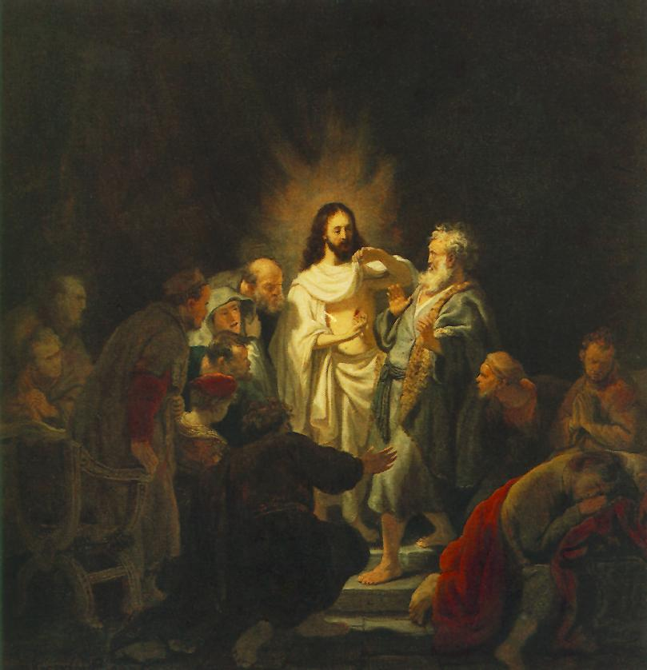
Picture of the Hollywood Dorian Grey Painting.

Read a Synopsis of The Picture of Dorian Gray
by Oscar Wilde (1856 - 1900)

