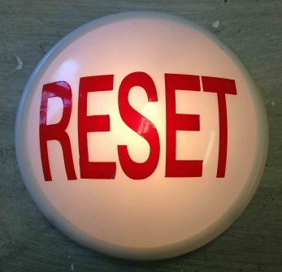
God’s Final
Reset Button
Family Worship Center, Sturgeon Bay WI 4/28/13
Pastor Mark Schwarzbauer PhD

Text: I Thessalonians 4:13-18

Reset One: The Reset Rapture
- The next event on the prophetic calendar (Chart).
- I Thessalonians 4:13-18.
- The Rapture- I Thessalonians 4:17
A. Jesus comes and takes the Christians away.
1. Catching away.
2. From the Latin Vulgate “rapiemur” “relinquimur simul rapiemur cum illis
a. The word "rapture" is in the Bible.
b. The Latin Vulgate was the common Bible of the church for over a thousand years.
B. The Rapture.
1. He brings with Him those who sleep.
2. The Lord Himself descends.
3. Voice of the Archangel & the trumpet of God.
4. The dead rise and are reunited soul and body.
5. We are "caught up" together with them to meet the Lord in the air.
IV. The Timing.
- No man knows the day or hour, Matthew 25:13.
- Like a thief in the night, I Thessalonians 5:2-4
- Sign of Israel, Matthew 24:32-34.
- One is taken the other left, Matthew 24:40-42.
- Imminent return (any moment unpredictably).
- http://ag.org/top/Beliefs/Position_Papers/pp_downloads/pp_4182_rapture.pdf
V. Reset Button -New Bodies rejoined with our spirits.

Reset Two: The Great Tribulation
- The Great tribulation (Chart)
- Matthew 24:21 – “Great Tribulation”
- Zephaniah 1:14-17 “Great day of the Lord”- “Day of Wrath”
- Daniel 12:3 – “Time of Trouble such as never was”
- Jeremiah 30:7 time of “Jacob’s Trouble” (Israel- God deals with Israel over rejection of Messiah)
- All three of these Old Testament passages use the same word for trouble.
- Seven Year period (Daniels 70th week in prophecy).
- Anti-Christ, a one world leader makes a 7 year covenant with the Jews. After 3.5 years he breaks it and demands worship. (Daniel 9:20-27),
- Forces everyone to accept him… mark of 666 (Revelation 13:11-18).
- God sends witnesses, judgments and more to deal with Israel and give a final opportunity for repentance.

Reset Three: The Second Coming
- Jesus actually returns to earth (Chart).
- Revelation 19:11-16
- Difference between Rapture and Second coming… church ascends, vs. Jesus comes back.

Reset Four: The Millennium
- 1000 Year Reign of Christ on Earth (Chart).
- Revelation 20:1-3.
- Satan bound and loosed at the end. (Chart).
- People still reject God with full knowledge and choose hell.

Reset Five: The Final Judgment
- Great White Throne Judgment (Chart).
- Revelation 20:11-15.
- Anyone not found written in the book of life is cast into the lake of fire.

Reset Six: The Final Reset
- The new heavens and the new earth (Chart).
- Revelation 21:1-5.
- God’s final reset button.
Reset Seven: Your Eternal Choice
- Revelation 21:6-8 (Chart).
- Overcome.
- Heaven or Hell is a choice made and lived out now.

Closing… Preparation and Comfort

Discussion Items and Questions for Home and Small Group
- Why do we need to be ready for the rapture?
- Why do you think God wants to restore things?
- Are you ready?
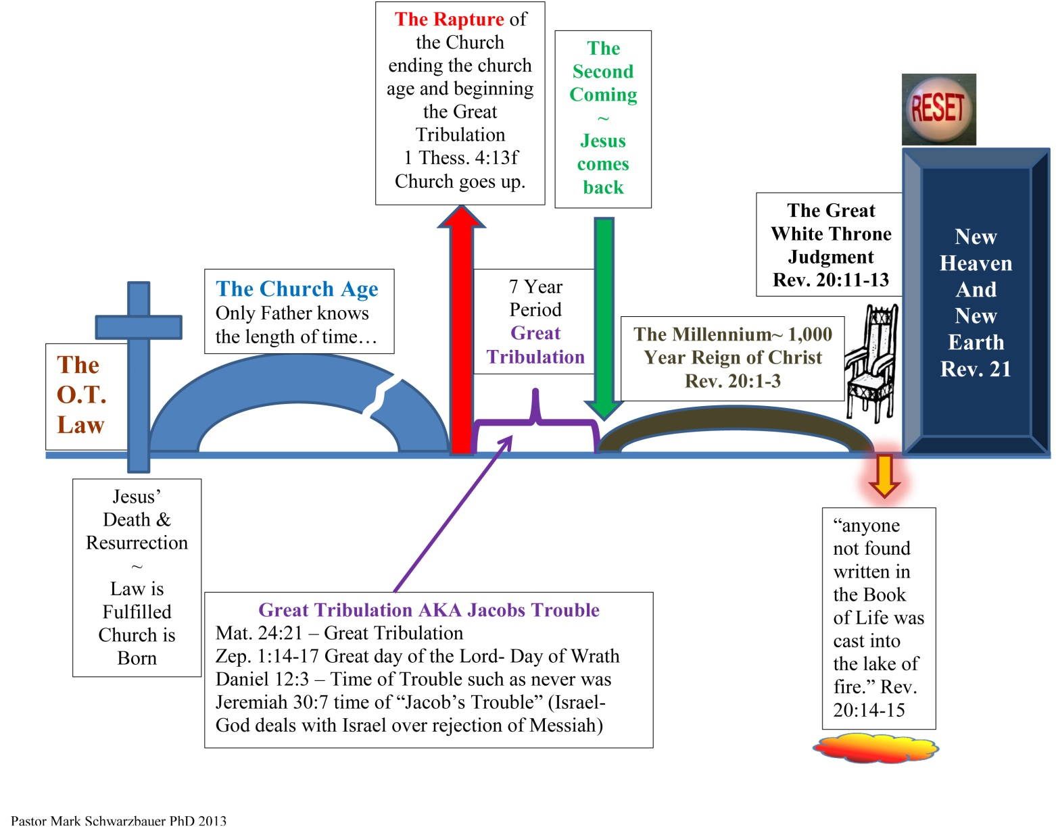
- Pray for each other.

